**Material 4 – Same and different – Ways to make friends.**

|  |  |
| --- | --- |
| Why? | **Aims and contents**  The activities aim to encourage children to:   * notice that all children have things in common; * notice that there are also differences; * learn basic ways to get to know other people; * develop the ability to understand others; * plan the first encounter with the partnership children.   **Targeted competences:**   * I can perceive similarities and differences (CARAP, skills, S-3.1) * I am open to the children of my partnership class (speaking another language/belonging to other cultures) (CARAP, attitudes, A-5) * I can plan the first encounter * I can plan/design something to offer to the host. |
| What? | Cultural similarities and differences.  Effective communication tactics in a multicultural and multilingual environment. |
| How? | **Same and different**  The teacher poses the following question: What do all children have in common?  He invites the pupils to contribute ideas, miming them.  The other children guess and try to verbalise what it is about.  Knowing what they have in common, children in groups talk about what they could offer to their partnership children.  The teacher poses the following question: Can you remember when you met someone who was differentfrom your self? Talk about the meeting and where it happened (see Autobiography of Intercultural Encounters).  **The first encounter**  Children suggest things that they could plan to do or to give to their partnership children (see material 7):   * greetings/smiles; * songs; * games; * stories; * food * …etc.   They project themselves into the first encounter. The activity can also be inspired by the Autobiography of Intercultural Encounters, see extract below.  They plan what to say to the partnership children (see material 5). |
| Product? | List of suggestions of things to plan or to give. |

Extract from the Autobiography of intercultural encounters for younger learners

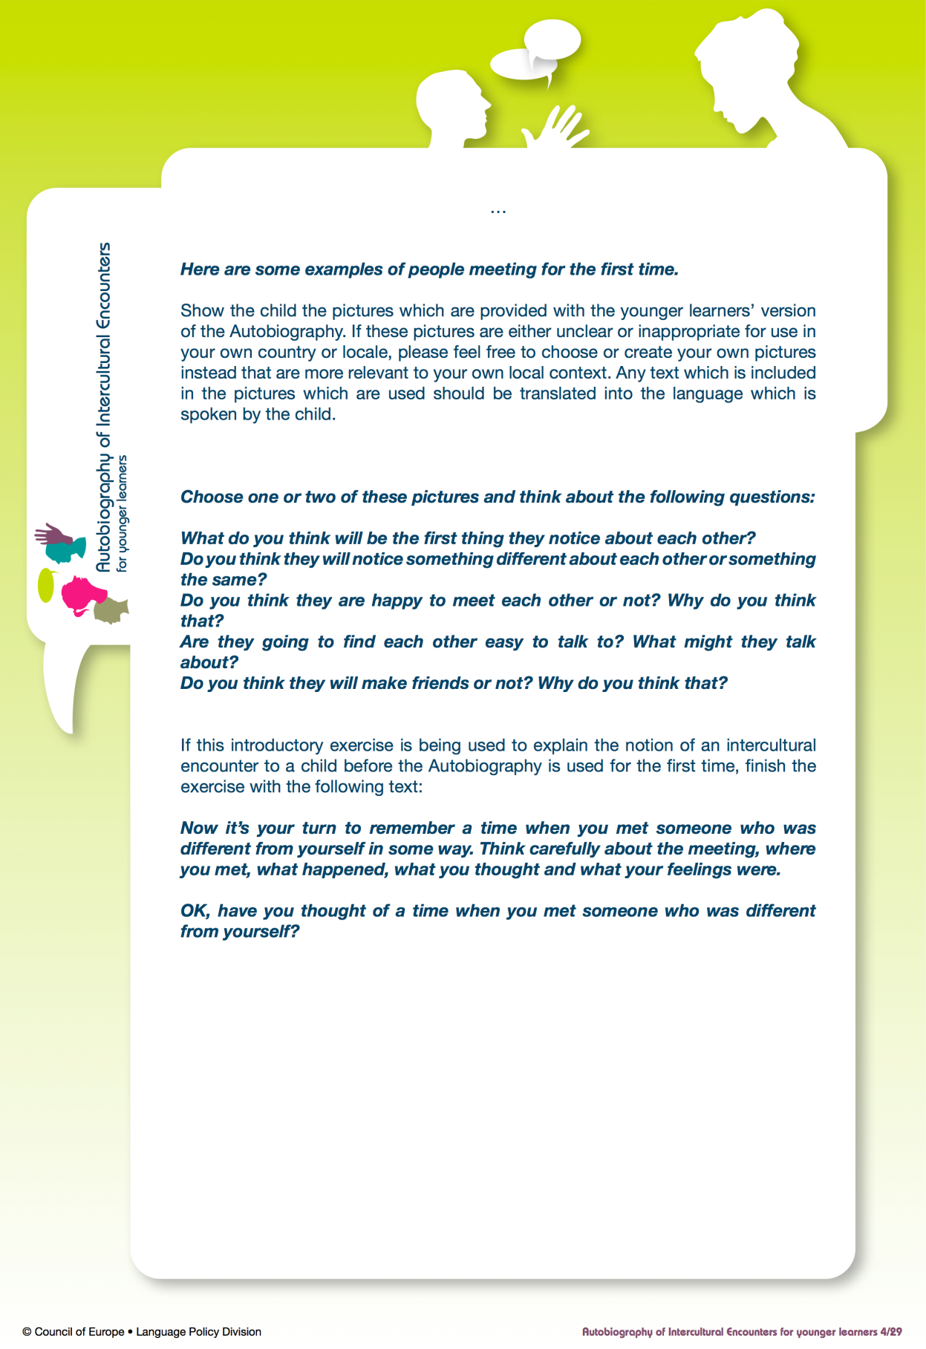 http://www.coe.int/t/dg4/autobiography/AutobiographyTool_en.asp